**AUTO-TUNING ALGORITHMS – FOR SUMMER WORKS IN ARCELIK**

This report contains practical and easy to use auto tuning algorithms for servo drive systems.

**1. OFF-LINE METHOD by Yang S.M., Lin K.W., Automatic Control Loop Tuning for PMAC Servo Motor Drives**

Used motor control – drive system:

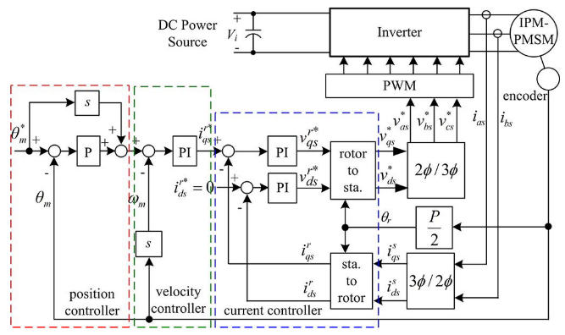

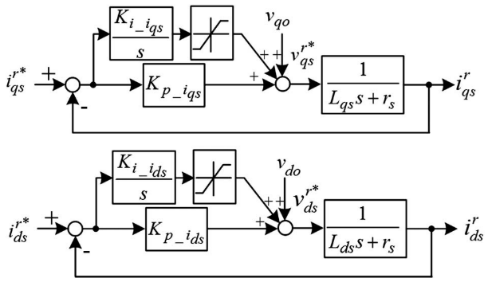 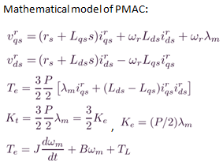

Where,

|  |  |  |
| --- | --- | --- |
| **Variables:** | **Electrical Parameters:** | **Mechanical Parameters:** |
| : rotor pole number | : Series resistance | : Electromechanical torque |
| : rotor electrical speed | : d-axis inductance | : Disturbance load torque |
| : rotor mechanical speed | : q-axis inductance | : Torque constant |
| : Laplace operator | : Back EMF constant | : Rotor and load inertia |
| : Back EMF+Cross coupling | : Rotor PM flux linkage | : Viscous friction coeff. |

The *cross-coupling voltages* ( )and the back EMF voltages are decoupled using the estimated electrical parameters and rotor speed.

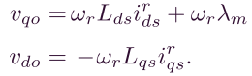

Simplified velocity control loop: Simplified position control loop: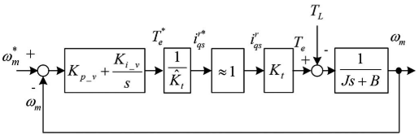 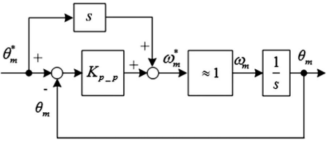

**Algorithm:**

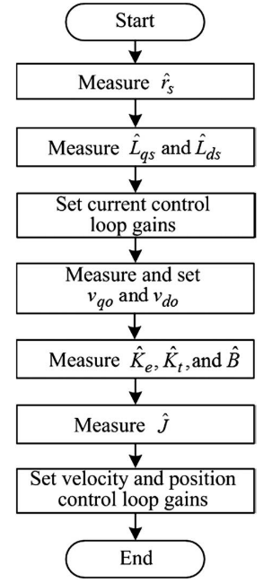

|  |  |
| --- | --- |
| **1.**  Electrical Parameter Estimation | **A) Series resistance**  To avoid error caused by rotor movements, resistance is measured by applying a *d-axis voltage pulses* as shown:  🡪  **B) Inductances ()**  The inductances are measured by applying voltage pulses to the q-and d-axes, and the peak currents are then measured for calculating the inductances.  🡪h<100us, d axis excitation time x2  Measure the peaks  Excite  of q axis excitation. Because of  Preventing the rotor movement.  Resistance drop neglected.  The d-q axes voltages are simplified as:  Inductances are approximately:  🡪 |
| **2.**  Current controller gains set after electrical parameter estimation | **A) Current PI Controller gains set**  The gains of the current controllers are designed for the ratio between the proportional and integral gains to cancel out the pole.  🡪 After this cancellation, q-axis closed loop transfer function :  🡪 : cutoff freq., it can be  set 10 of velocity loop.  The gains can be set as:  🡪 The d-axis gains can be similarly determined.  **B) Velocity PI Controller gains set**  🡪 After this assumption, velocity closed loop transfer function :  🡪 : cutoff freq., it can be  Higher than position loop.  The gains can be set as:  🡪 must known for initial set  **C) Position P Controller gain set**  🡪Similarly, assuming that the bandwidth of the velocity control loop is  much higher than that of the position control loop.  **Remark:** |
| **3.**  Feedforward voltages and torque constant, mechanical parameters | Although the resistance and inductance measurements are static, the rotor must move to measure the feedforward voltages, torque constant, and mechanical parameters. So we apply current when is set to zero.    Note that is approximately half of the rated speed because the integrator voltages are limited to half of the rated phase voltage.  @t=t1, Back EMF - torque constant, and PM flux are estimated as:      @t=t2, calculate:    @t=t3, when the motor speed reaches a preset speed , the current command is set to zero for a short period of time to end the acceleration, the speed control loop is closed, and the command is set to . Estimate , assume =0, =slope to :  🡪 is not accurate,  temporary value up to t4-t5  During [t3,t4],average is calculated and denoted as  @t=t4, the motor reached a steady-state speed. can be calculated as:    After the estimation of , all of the controllers were switched off, and the motor decelerated down to zero speed.  @t= t4~t5, the motor speed in this region can be expressed as:    The inertia calculated using curve fitting is more accurate than because it is less sensitive to measurement noise. After that, the velocity and position control gains were calculated using step 2. |

**2. RESONANCE FREQ DETECT by Yang S.M., Lin K.W., Detection of Resonance Freq. In Motion Control Systems**

The proposed scheme uses *velocity error* as the source for vibration frequency detection. In the beginning of the vibration frequency tracking process a segment of velocity errors are sampled and stored, denoted as .

System scheme:

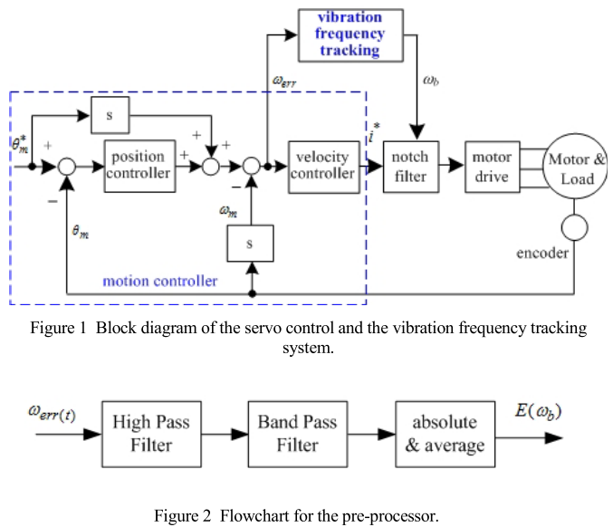

A high-pass filter is used to remove low frequency and DC components in the velocity errors first. Then, a band-pass filter is applied to discriminate frequency contents of the errors.

The transfer function of the band-pass filter can be expressed as:

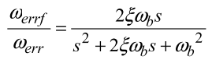

ζ is a constant, is the frequency of the band-pass filter, and is the filtered output.



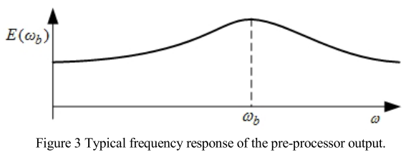

The algorithm of freq. Tracking (look like MPPT algorithm in PV):

In the proposed scheme resonance frequency tracking is performed when the motor is running at constant speed or at standstill. Before the process begins, a segment of velocity errors is sampled and stored. The tracking process is iterating by varying .

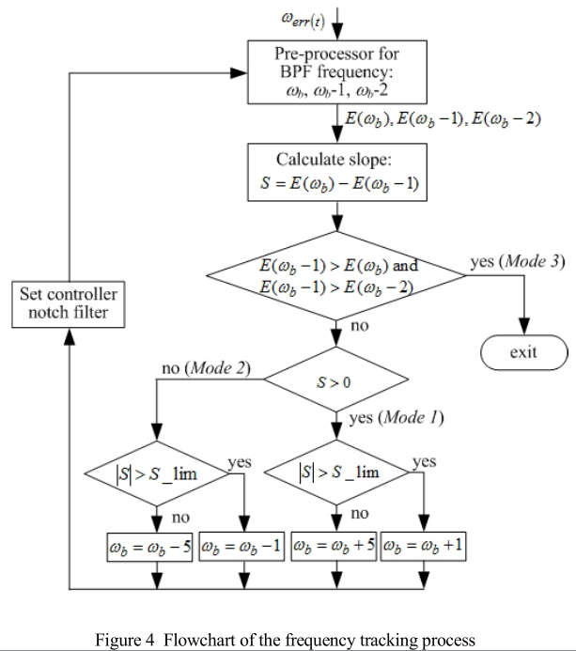

*S= After the pre-processor the slope between E(ωb) and E(ωb-1) is calculated

Upon completion of each tracking is checked to see if the amplitude of the oscillation is large enough for the initiation the controller notch filter. The E limit is set to about 20rpm oscillation of the velocity error. The frequency of the notch filter is set to if is greater than this value, otherwise it is disabled before the next tracking begins.